**Practical 9**

**Aim: Using Document-based Database - MongoDB**

**What is a Document based Database ?**

A Document based Database Model is a lot different than other data models because it stores data in JSON, BSON, or XML documents. In this data model, we can move documents under one document and apart from this, any particular elements can be indexed to run queries faster. Often documents are stored and retrieved in such a way that it becomes close to the data objects which are used in many applications which means very less translations are required to use data in applications. JSON is a native language that is often used to store and query data too.

**MongoDB** is an open-source document database and leading NoSQL database. MongoDB is written in C++. This tutorial will give you great understanding on MongoDB concepts needed to create and deploy a highly scalable and performance-oriented database.

1. Creating and using database

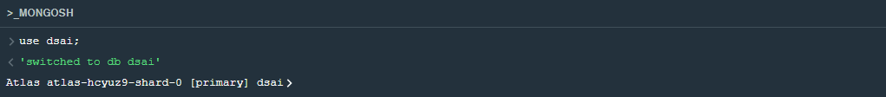

1. Dropping a database



1. Creating and dropping collections

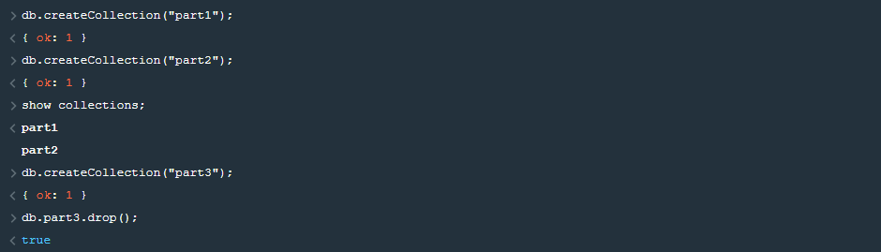

1. Adding data into document

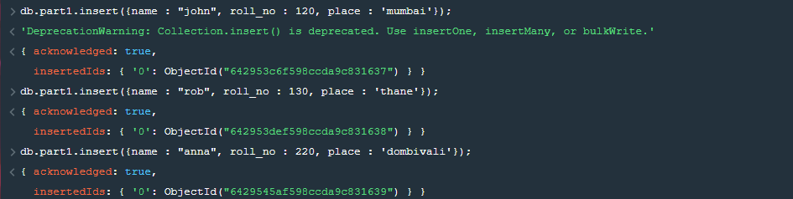

1. Displaying all data from document

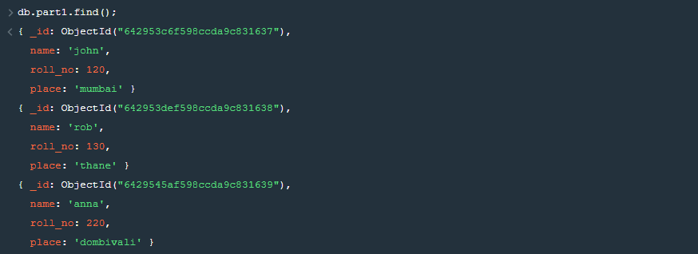

1. Updating a record

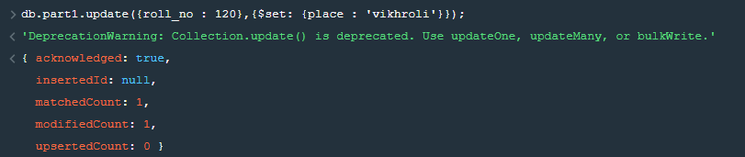

1. Removing a record



1. Projection

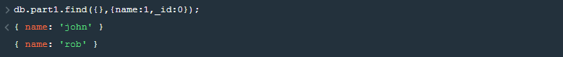

1. Limiting records

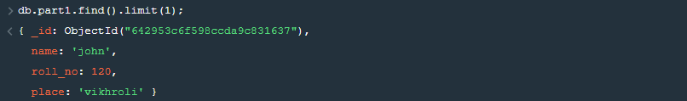

1. Sorting records

